**Post-Lab 7 Report       Calvin Ton**

ECE 100-02 Teammates: Danny F., Jose C.

Prof. Oruklu Lab Date: 10/24/18

TA: Matthew Francis Due Date: 10/31/18

**Problem Statement (Proposal)**

Design an autonomous robot that will be able to scan a black board and search for pucks in the tape path. In addition, collect the puck and return it to a designated area in less than the provided time.

**Investigation/Research**

From forward and backward functions to touch and light sensors, groups must compete against each other in a battle of pucks, the “Mint Shuffle X”. The objective of the game is for the robot to quickly search and approach a puck, so it can grab the puck and return it back to the base, the white triangle. In addition, the robot must take the remaining pucks and push them to them to the opponent’s side of the board. Multitasking is “where the robot has several ‘behaviors’ running at the same time” (Martin 209). In order to make the robot multitask, touch sensors and light sensors must be used to successfully beat the opposing team. Recalling the purpose of touch sensors, if a bump is registered on one side of the robot, then it should react and turn and go forward in the opposite direction from the bump. Instead of only having touch sensors, light sensors can also assist the robot in beating the opponent’s robot. Light sensors provide light readings based on how bright a light is. The lower the reading, the brighter the light, and the higher the reading, the lower the light. Therefore, since the robot is utilizing both touch sensors and light sensors, it will have more code to run through and execute, causing it to run more than one behavior at an instant.

The pucks will be placed on the tape while the robot will start in one of the corners. When the time starts, the robot will move forward to look for any light. Once the robot picks up the light from the tape, the robot will follow the white tape and eventually encounter a puck. The robot will then turn based on how the puck hits the touch sensors. An important aspect of the game is that a team’s robot is not allowed to cross over to the opposing team’s board; therefore, a wandering function and periodic turn must be incorporated. The wandering function causes the robot to “simply drive straight ahead” and then periodic turn “will kick in every” x number of seconds, causing the robot to “veer from a straight-line path” (Martin 212). The time that the robot will periodically can be adjusted according to the size of the team’s board. After the robot returns the first puck to base, the wandering and periodic turn function should begin running so that the robot and find a puck and dump it on the opponent’s side of the board and the perfect time so that the opposing team’s robot is not able to return it in time. If these actions can be successfully coded, then the robot should exhibit astonishing performance.

**Alternate Solutions**

/* grchmain.c */

void groucho()

{

while(1) {

inside_corner(); /* position 1 to 2 */

drive_to_top(); /* 2 to 3 */

align_with_edge(); /* 3 to 4 */

follow_edge_to_wall(); /* 4 to 5 */

dump_ball_shuffle(); /* 5 to 6 to 7*/

drive_to_bottom(); /* 7 to 8 */

inside_corner(); /* 8 to 9 */

}

}

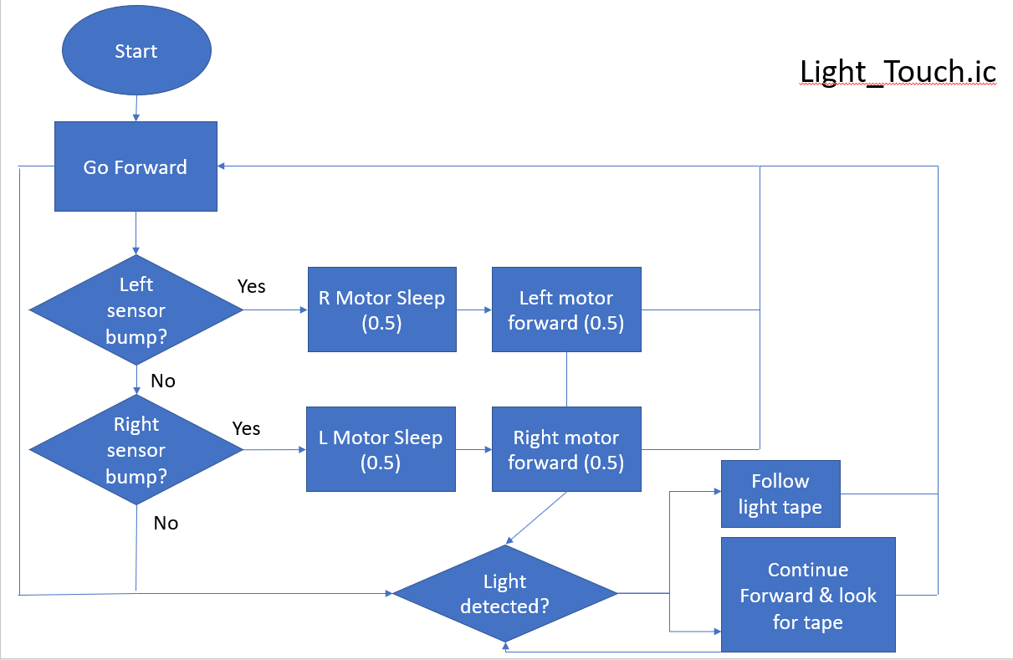

Light_Touch.ic is an idea that utilizes both the light and touch sensors. The process starts with the robot moving forward and checking for either a bump or any light the is present. This is the multitasking aspect that is incorporated into the robot where the robot will operate both codes simultaneously. If there is no bump, the robot will look for the tape and will continue looking for a tape. If the robot detects a bump from the puck, it will turn the opposite way and either continue forward or look for the tape to lead it to the base.

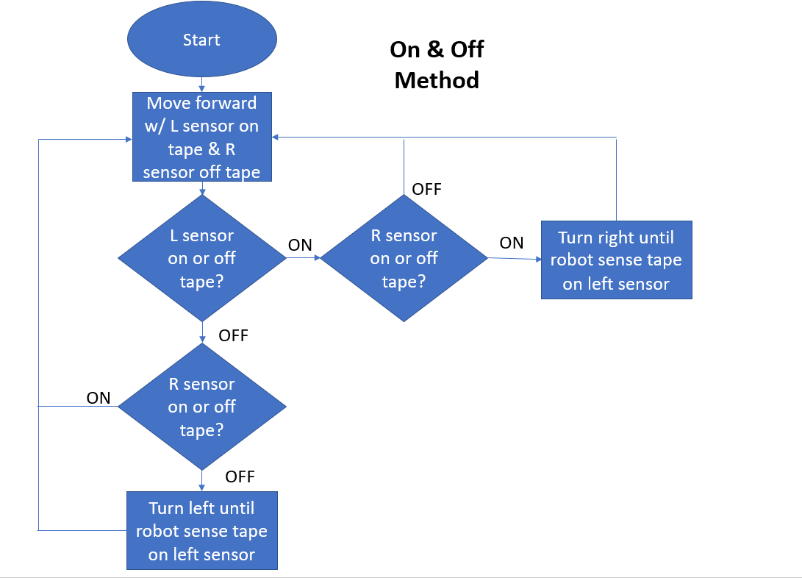

This code is from the previous competition where one sensor stays on the tape while the other stays off the tape. By using this code, the robot will be able to follow the white tape once the sensor encounters the tape. In addition to this code, the first part of the competition, when the robot needs to return one puck back to base, it will be hard coded so that it is able to gain the first easy point. After, this code will then run so that it can follow the white tape along with the wandering function and periodic turn to push the remining two pucks to the other side of the board.

**Optimum Solution**

Realizing that touch sensors would not be useful for this competition, it was decided that only light sensors would be utilized so that the robot can follow the white pieces of tape. Using the code from the previous competition along with more added on, the robot would be able to return the first puck solely off hard coding since the puck closest to base will always be in the same position. Once the robot finishes executing the hard code, it then goes into the one off and one on method. This is the best solution because it becomes difficult because the robot will end up follow the first tape but not turning around to retrieve the other pucks. If the robot were to only function off hard coding, it would not be heavily reliable; therefore, there needs to be a balance between hard coding and manual coding from the previous competition. During the competition, the game will last 90 seconds. It would be best if the robot started a little later rather than earlier because if the last two pucks are pushed to the other side too early, the opposing team’s robot will push it back, leaving no time left for the robot to return them to the other side.

**Milestone Report (Analysis/Testing, Construction/Implementation, Final Evaluation)**

After careful consideration of constructing the physical body of the robot, it was decided that the sensors would be place facing inwards (closer to the body rather than further) along with the right extender being further away from the robot. Having the sensor closer to the body allows the robot to follow the white tape in a more proficient way. In addition, the right extender of the robot is placed more outward because the robot will run on the tape with the left sensor above the tape and the right sensor off the tape. The left extender will also be slightly above the tape; therefore, the right extender needs to be further away from the body so that it can easily retrieve the puck with a bigger distance between the left and right extender. Along with the sensors being pointed inward and the extenders having a big distance between them, an 8-tooth gear was placed on the motor while a 40-tooth gear was placed on the axle for a steady yet fast speed. If the robot were to be too fast, then the sensors would not keep up and detect the white tape quick enough.

During the testing process, the robot would steer to the left instead of proceeding on a straight path. This was because one motor was faster than the other, so a code was added and modified so that both motors were able to run at the same speed, allowing the robot to move forward in a straight path without any other problems. In addition, the robot was also able to return the first puck back to the white triangular base, but it was not able to turn around in order to retrieve the other pucks to push to the opposing team’s side of the board. To fix this, the robot needs to be hard coded to retrieve and return the first puck back to the base. After, more code can be added so that the robot can execute a 180 degree turn and follow the white tape. From there, the robot should be able to find the other pucks to push to the other side. To hard code the beginning of the of the competition, the robot needs to be timed to see how long it takes to get the first puck and how long it takes to return the puck to the base. Finally, a function was added to the end of the code so that the robot would not start running until the “START” button was pushed. This allows the robot to be placed and repositioned so that it can move forward in the desired direction.e

For the next lab, the primary focus is the coding to make the robot complete the objectives of the game.

**References**

1. Martin, Fred G. 2001. Robotic Explorations: A Hands-On Introduction to Engineering. New Jersey: Prentice Hall.

2. Oruklu, Erdal. 2018. ECE 100 Lecture Notes. Chicago: Illinois Institute of Technology, Electrical and Computer Engineering Department.

**Appendix**

